Simon Chow, Eric Li

10/31/17

CISC 1600 EW6

Project 2

**Interactive Kite Animation with Day / Night Cycle**

Our program is a basic interactive graphical program written in Processing language. The main focus is a kite that the user can control and change the color of. There is also a day and night cycle with the corresponding sun or moon that also automatically. There is a cloud that travels across the screen, changing color depending on what part of the day and night cycle the program is currently in. During the night part of the cycle, there are stars that flash in random positions.

In terms of animation and interaction elements, the kite can be moved via user input utilizing 4-axis movement (left, up, right, and down directions). There are three kite tails that are animated automatically, not requiring user input. The kite string is a bezier curve that is anchored to the bottom left of the display window; the string automatically adapts depending on the current position of the kite. The color of the kite and the kite tails can be changed by the user via hotkeys that are displayed to the user on the start screen. Speaking of the start screen, it has an event handler to determine when the animation should be started. Back to the actual animation, the user can change the time of day through a day and night cycle with a left mouse button click. The background will change color accordingly and the sun or moon will move off-screen and its counterpart will move on-screen in a predefined arc. During the night part of the cycle, stars will appear and flash in random positions. There is also a cloud that changes color depending on the which part of the day and night cycle the program is in. It automatically moves across the screen; when the cloud moves off-screen, it loops back to the beginning.

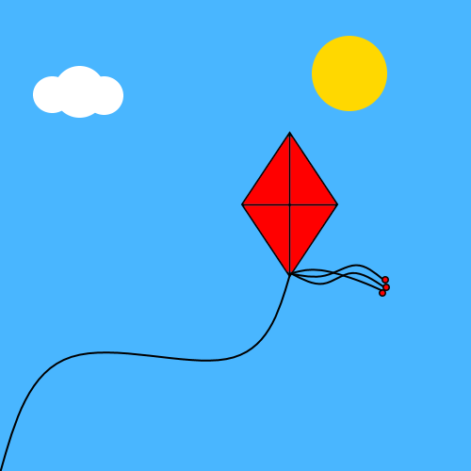

We originally wanted the kite tails to react to user input (ie. the kite tails should flow to the right when the user moves the kite left and vice-versa). We could not figure out a way of doing this short of copying the kite tail animation code and editing each coordinate manually which was not feasible in terms of time constraints, efficiency, and general code legibility. We also wanted the stars to flash a few times before the next set of random stars were drawn to the screen. This was too difficult to implement without rewriting a large portion of our code; we instead opted to lower the frequency of new stars appearing.